**SHIMONI DEMONSTRATION SCHOOL-KIRA**

**MID TERM TWO EXAMINATIONS, 2024**

**PRIMARY TWO ENGLISH**

**Name: -----------------------------------------------------------**

**SECTION A**

**Make correct words.**

1. formuni -----------------------
2. llowye ----------------------------
3. thtoo ------------------------------

**Fill in a letter.**

1. paw----aw
2. hap---y
3. medi---ine

**Arrange in ABC order.**

1. car ,bed ,driver

--------------------------------------------------------------------------------

1. walk ,pray , read

---------------------------------------------------------------------------------

1. red, blue , green

------------------------------------------------------------------------------

**Give the plural. (many)**

**one Many**

1. broom -----------------------------
2. child --------------------------------
3. brush -----------------------------

**Find a small word.**

1. Grandfather ------------------
2. Mango -----------------------------
3. Meat -------------------------------

**Use the correct word.**

1. Children ____________ potatoes. (it, eat)
2. I can ------------------------ the bird singing. (here, hear)
3. Joseph is your ----------------.(sun ,son)

**Write one word.( Use: under ,to, between ,in)**

1. The teacher is going -------------------- school.
2. The patient is -------------------------- the hospital.

**Answer the questions.**

**How many ------------ have you?**

**I have­­­­­­­­­­­­­­­­­­­­­­­­­­­­­­­­---------------------------------**

1.  I have --------------------------

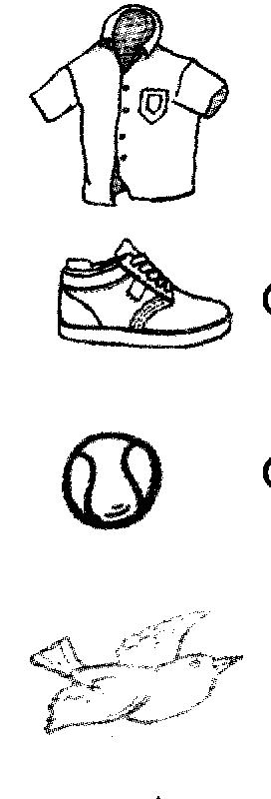

1.  I have --------------------------

D:\diagram\an eye.tifD:\diagram\an eye.tif

1. I -------------------------

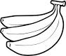

1. I ----------------------------bananas.

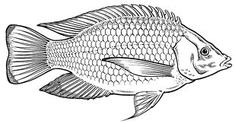

1. I ----------------------------

**Add ---------ing1**

1. I don’t like ---------------------------- (fight)
2. We like -------------------- ( play)
3. They don’t like------------------ (steal)
4. You like ------------------- books.(read)
5. The children like -------------(wash)

**SECTION B**

**51. Make correct sentences from the table.**

|  |  |
| --- | --- |
| **A** | **B** |
| Mr. Gomba | to touch |
| A carpenter | washing her dress |
| The teacher | is my grandfather |
| The girl is | makes chairs |
| I use my hand | Is in a school |

------------------------------------------------------------------------------------------------------------------------------------------------------------------------------------------------------------------------------------------------------------------------------------------------------------------------------------------------------------------------------------------------------------------------------------------------------------------------------------------------------------------------------------------------------------------

**52 Read the story. Answer the questions.**

**THE GOOD TEACHER**

My teacher is Miss Akello. She is a good teacher. She is teaching English. She wants our books. She tells us to read. We read . She is happy. We say thank you.

1. Who is my teacher?

My teacher -----------------------------------------------

1. Is she a good teacher?

Yes,-----------------------------------------------------------

1. What is she teaching?

She is -------------------------------------------------------

1. What do we say?

We say ------------------------------------------------------

1. Write the title of the story.

-------------------------------------------------------------------------

**53. Make a good story.**

1. He takes the water home.
2. Every day, Tim goes to the well.
3. He washes his shirt.
4. His shirt is clean.
5. He gets water.

**Good Story**

-----------------------------------------------------------------------------------------------------------------------------------------------------------------------------------------------------------------------------------------------------------------------------------------------------------------------------------------------------------------------------------------------------------------------------------

**54.Read the poem. Answer the questions.**

**MY BODY**

I love my body

I have a head

It has two eyes

They help me to see

I have two arms

They have fingers

There are ten fingers

They help me to write

**By Cissy**

1. What do I love?

--------------------------------------------------------

1. Where are the eyes?

---------------------------------------------------------

1. How many fingers do I have?

-----------------------------------------------------------

1. Who wrote the poem?

----------------------------------------------------------------

1. Write the title of the poem.

----------------------------------------------------------------------